**Types of data analytics**

There are 4 different types of analytics. Here, we start with the simplest one and go further to the more sophisticated types. As it happens, the more complex an analysis is, the more value it brings.

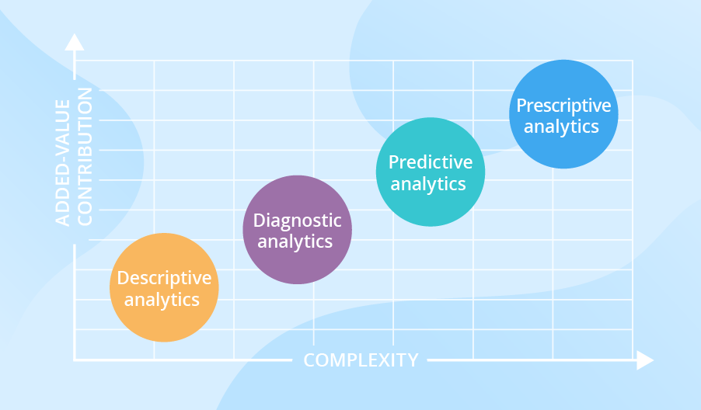

### Descriptive analytics

Descriptive analytics answers the question of what happened. Let us bring an example: having analyzed monthly revenue and income per product group, and the total quantity of metal parts produced per month, a manufacturer was able to answer a series of ‘what happened’ questions and decide on focus product categories.

Descriptive analytics juggles raw data from multiple data sources to give valuable insights into the past. However, these findings simply signal that something is wrong or right, without explaining why. For this reason, our data consultants don’t recommend highly data-driven companies to settle for descriptive analytics only, they’d rather combine it with other types of data analytics.

### Diagnostic analytics

At this stage, historical data can be measured against other data to answer the question of why something happened. For example, to see how a retailer can drill the sales and gross profit down to categories to find out why they missed their net profit target. Another flashback to our data analytics projects: in the healthcare industry, customer segmentation coupled with several filters applied (like diagnoses and prescribed medications) allowed identifying the influence of medications.

Diagnostic analytics gives in-depth insights into a particular problem. At the same time, a company should have detailed information at their disposal, otherwise, data collection may turn out to be individual for every issue and time-consuming.

### Predictive analytics

Predictive analytics tells what is likely to happen. It uses the findings of descriptive and diagnostic analytics to detect clusters and exceptions, and to predict future trends, which makes it a valuable tool for forecasting. Advanced data analytics allowed a leading FMCG company to predict what they could expect after changing brand positioning.

Predictive analytics belongs to advanced analytics types and brings many advantages like sophisticated analysis based on machine or deep learning and proactive approach that predictions enable. However, our data consultants state it clearly: forecasting is just an estimate, the accuracy of which highly depends on data quality and stability of the situation, so it requires careful treatment and continuous optimization.

### Prescriptive analytics

The purpose of prescriptive analytics is to literally prescribe what action to take to eliminate a future problem or take full advantage of a promising trend. An example of prescriptive analytics from our project portfolio: a multinational company was able to identify opportunities for repeat purchases based on customer analytics and sales history.

Prescriptive analytics uses advanced tools and technologies, like machine learning, business rules and algorithms, which makes it sophisticated to implement and manage. Besides, this state-of-the-art type of data analytics requires not only historical internal data but also external information due to the nature of algorithms it’s based on. That is why, before deciding to adopt prescriptive analytics, it is strongly recommended to weighing the required efforts against an expected added value.

## What types of data analytics do companies choose?

To identify if there is a prevailing type of data analytics, let’s turn to different surveys on the topic for the period 2016-2019.

For the [2016 Global Data and Analytics Survey: Big Decisions](http://www.pwc.com/us/en/advisory-services/data-possibilities/big-decision-survey.html), more than 2,000 executives were asked to choose a category that described their company’s decision-making process best. Further, C-suite was questioned with what type of analytics they relied on most. The results were the following: descriptive analytics dominated (58%) in the “Rarely data-driven decision-making” category; diagnostic analytics topped the list (34%) in the “Somewhat data-driven” category; predictive analytics (36%) led in the “Highly data-driven” category.

The survey findings are in line with ScienceSoft’s hands-on experience as they show the need for one or the other type of analytics at different stages of a company’s development. For example, the companies that strived for informed decision-making found descriptive analytics insufficient and added up diagnostics analytics or even went as far as predictive one.

For another survey, [BARC’s BI Trend Monitor 2017](https://bi-survey.com/predictive-analytics),2,800 executives shared their opinion on the growing importance of advanced analytics. The term advanced analytics was the umbrella term for predictive and prescriptive analytics types.

According to the [2018 Advanced and Predictive Analytics Market Research](http://dresneradvisory.com/products/2015-advanced-and-predictive-analytics-market-study-report), advanced analytics was for the first time considered “critical” or “very important” by a majority of respondents.

Within the [BARC's BI Trend Monitor 2019 survey](https://bi-survey.com/top-business-intelligence-trends), C-suite still named advanced analytics among the most important business intelligence trends.

## What types of data analytics does your business need?

To define the right mix of data analytics types for your organization, we recommend answering the following questions:

* What’s the current state of data analytics in my company?
* How deep do I need to dive into the data? Are the answers to my problems obvious?
* How far are my current data insights from the insights I need?

The answers to these questions will help you settle on a data analytics strategy. Ideally, the strategy should allow incrementally implementing the analytics types, from the simplest to more advanced. The next step would be to design the data analytics solution with the optimal technology stack, and a detailed roadmap to implement and launch it successfully.

You may try to complete all these tasks with the efforts of an in-house team. In this case, you’ll need to find and train highly qualified data analytics specialists, which will most probably turn lengthy and pricey. To maximize the ROI from implementing data analytics in your organization, we advise you to turn to an experienced data analytics provider with a background in your industry. A mature vendor will share the best practices and take care of everything, from the analysis of your current data analytics state and selection of the right mix of data analytics to bringing the technical solution to life. If the described approach resonates with you, our data analytics services are at your disposal.